|  |
| --- |
|  |
| TrackMyWords – User Manual |
| Comp231-062 |
| **Taras Paniuta – 300795251**  **Amina Abbasi – 300703899**  **Navpreet Singh – 300775872**  **Luke Farnell – 300700511**  **Joanne Tanson – 300767984**  **Andrew Cumming – 300695420**  **Aakash Jain – 300795874** |
|  |
|  |

|  |
| --- |
|  |

# Search Screen

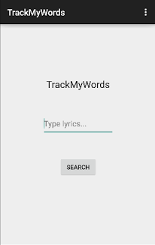

Search Screen

1

2

This is the first page of our app, TrackMyWords. On this screen, there is a spot to type in the lyrics you want to search for in our database (1). Once you type in the lyrics, the search button needs to be selected/clicked (2) in order for the app search the database for the song containing the lyrics. When a User wants to search for a song, they first press on the spot where it says “Type lyrics…”(1).

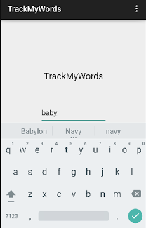

4

3

5

The “Type lyrics…” will disappear and a keyboard (3) will show up when the user wants to search for a song. The user will type in the space provided (4) and then press the checkmark (5) once they complete the lyrics.

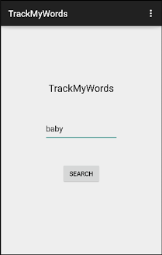

6

7

The User’s query will show up (6) and they will have to press “Search” (7) in order to execute the query.

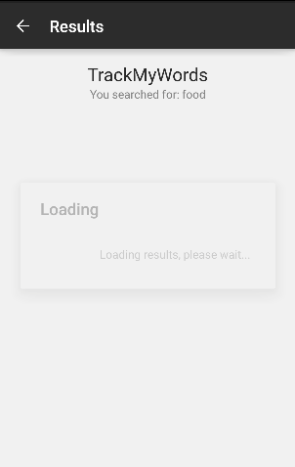

Loading Screen

Once “Searched” is selected, the Loading screen will show up looking for the queried results.

# Results Page

Figure A

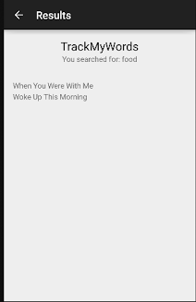

Figure B

8

If the lyrics queried are in the database, then this result page will be displayed (8). It will display all the songs that contain the lyrics the user searched for. Figure A shows the Result Page with a scroll bar. This appears when all the songs queried cannot fit onto a page. Figure B shows all the songs queried that can fit onto a page and does not require a scroll bar. The User can select the song from this page and it will go to the Lyrics page, which will contain artist, album and the lyrics for that song.

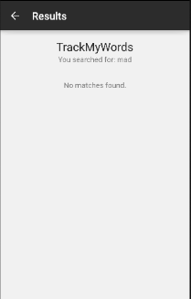

Figure

If the User’s search did not find any songs that contained the lyrics they were looking for, a “No Matches Found” message will appear (Figure C).

# Lyrics Page

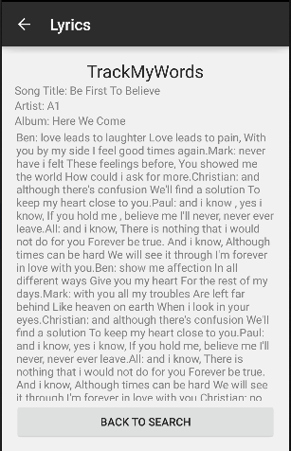

9

Figure

Once the User selects a song, the “Lyrics” page will show up (Figure D). This page will contain the song’s title, artist, album and the lyrics for the song. Users can scroll down the page to see the rest of the lyrics. The User can also go back to the “Search Screen” by pressing the “BACK TO SEARCH” button (9).

# Admin -